1-a. Add a feature to the expression parsing code

I added a feature to take the integer that was passed in and assign it to bottles minus 1. But only if the integer passed in is 100. It will then also print “99 bottles to go”

Finally, whatever integer is passed in parse_integer returns the same number.

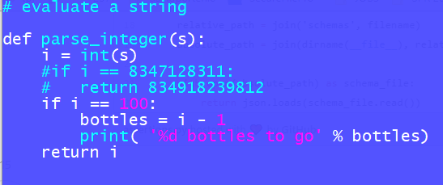

1-b. Verify through testing with pytest and direct connection that the expression parser works on some feature you have added.

I created a “**direct_test_evaluate.py**” to check if the parse_integer() expression parsing code was working correctly:

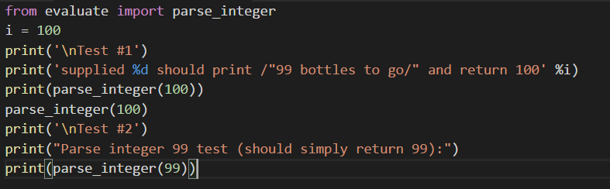

Output:

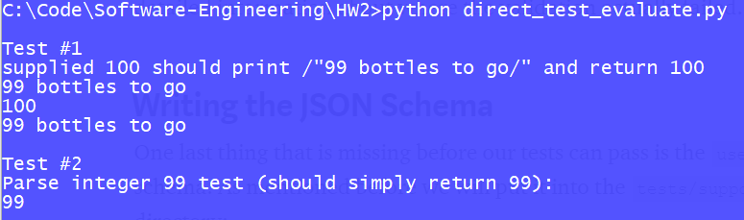

2. Verify using requests and pytest that some API on this list works correctly:

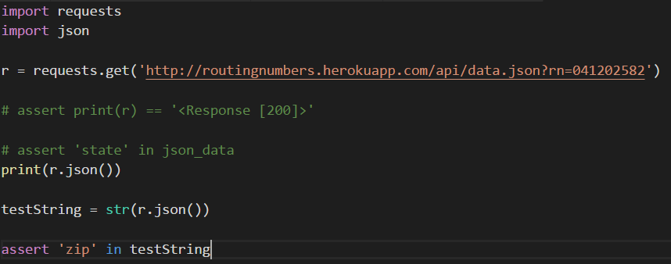

I chose to verify a bank routing number API. I tried doing this a number of ways, and settled on searching for an element that I knew was in the returned json data – “zip”

After running the test, I got the following result:

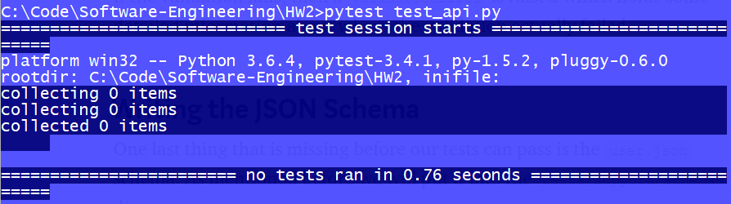

3. Verify using webdriver and pytest that either "Oster" or "Hamilton Beach" is one of the blenders brands sold on Amazon on the "blender" search page.

I installed Selenium thinking that it would also include the webdriver.exe. I added Selenium to my windows path, but still could not get it to work. I found the webdriver.exe file online and then installed in my directory with the python tests. It worked! However, when I committed the changes and pulled them in to my other computer it stopped working. I tried downloading chromewebdriver.exe and selenium again. I already had selenium. I added multiple paths and then finally looked at the code. The problem was I had a comment that I forgot to hash #. Verified it works.

